SMART FLOOR CLEANING SYSTEM

Mr.Shivakumar K V1,Mr.Prasanna Kumar B I2,Mr.Shashank Swami3,

Mr.Shashank Viresh Shetti4,Prof.Sudhakara H M5

1Alvas Institute of e Engineering and Technology/Electronics and Communication,Manglore,India

[4al21ce079shiva@gmail.com](mailto:4al21ce079shiva@gmail.com)

2-5Alvas Institute of e Engineering and Technology/Electronics and Communication,Manglore,India

2-4{4al21ec064,4al21ec077,4al21ec78}@gmail.com,5sudhi123@aiet.org.in

***Abstract-***

**The intelligent floor cleaning system is a cutting-edge technology that automates and enhances procedures. The system uses superior technology such as robotics, sensors, and artificial intelligence to accomplish self-cleaning functions. The equipment possesses different sensors that enable it to detect obstructions, move around sophisticated environments, and identify various types of dirt and garbage. It employs smart algorithms to optimize cleaning patterns and adjust to different floor surfaces. The system also features remote control, scheduling, and real-time monitoring through mobile apps. The intelligent cleaning solution minimizes human labor, increases cleaning consistency, and improves overall hygiene levels in residential and commercial environments. IoT (Internet of Things) technology integration allows data collection and analysis. Facilitating continuous improvement in cleaning performance and energy efficiency. This abstract presents the smart floor cleaning system, its main components, and potential advantages in contemporary cleaning processes.**

***Keywords***—*Arduino Uno, Servo motor, Moter driver L298N, Water Pump, DC Motors, Bluetooth Sensor HC-O5*

1. INTRODUCTION

Cleaning is an obligation, but most people ignore it due to their busy schedules. Employing conventional cleaning processes can be tiresome and time-wasting. Cleanliness is, however, essential to physical health, mental well-being, and work efficiency. To address this, innovative ways of cleaning, especially floor scrubbers, have been developed. The earlier models had flaws such as inefficiency and complex wiring, which made them hard to operate. Now, the intelligent floor cleaning system offers a breakthrough by working independently, eliminating the necessity of manual cleaning. This machine saves time, energy, and effort by performing dry cleaning tasks at once. Most people find it difficult to clean their homes daily, but this method makes it easy for them to keep their homes clean. A clean environment reduces dust and germs, leading to a healthier and more comfortable environment while reducing stress. In addition, companies are advantaged by this approach as it provides an inexpensive option to maintain offices in a clean state without the need to employ more staff. Conventional cleaning processes are labor-intensive, but intelligent technology makes the process quicker and more effective.

1. LITERATURE SURVEY

The writer examines how science in the modern world keeps getting better in terms that simplify everyday life. An example of such technology is the Smart Floor Cleaning Robot, which is designed to clean floors automatically. The writer explains the importance of hygiene and cleanliness, noting that hectic lifestyles often leave individuals with no time for domestic chores. The robot tackles that problem by offering remote control through a built-in Wi-Fi module [1].

The robot is furnished with a small vacuum cleaner to collect dust and a motor-driven mop that removes dirt from the floor using water. The ease of emptying the vacuum once cleaning is complete is highlighted by the author. Advances in future technology, such as mapping, will enhance the ability of the robot to clean all parts of space efficiently. The intention of the author in this project is to develop a simple yet efficient robotic system for automatic floor cleaning [1].

The author explains the design of an automatic cleaning robot that will automate and mechanize household cleaning operations. The robot's primary function is to minimize the amount of manual input taken in the cleaning process. The proposed system involves both vacuum and mopping. The mopping system is composed of a mop attached to a small water reservoir, which keeps the mop wet to improve the cleaning effectiveness of the floor. In contrast, the vacuum system involves a vacuum pump that traps dust particles. The whole system, both hardware and software processes, is controlled by an Arduino Mega microcontroller [2].

A GSM module is employed for wireless communication between the user and the robot. An acknowledgment message is sent by the robot to the user when the robot is switched on or when a mop replacement is required. Users can select wet and Dry Cleaning modes based on preference. Besides remote on-off, the robot is also switched on and off manually through external switches. Sweeping and mopping operations are carried out by the robot, and it is also provided with an obstacle detection feature and collision-free navigation to ensure efficient cleaning as per the user's instructions [2].

The author discusses the uses and benefits of intelligent floor-cleaning robots in various places, including residential areas, airports and railway stations, hospitals, bus stations, shopping malls, and other commercial areas. The traditional approach of cleaning with brooms and mops has been replaced by robots, which increase working efficiency and reduce physical labor. The robotic machine is controlled by an Arduino controller, which controls its operation [3].

The robot system can undertake various cleaning activities such as sweeping, mopping, dusting, and sanitizing surfaces. It works on its own, maintaining the floor clean without the intervention of human beings. While running on power, the robot can clean and maintain the environment hygienic across the entire house, thus saving labor. The machine system is independent, making it an effective and reliable method for modern cleaning purposes [3].

The writer speaks of the quick advancement of science and technology, both of which are constantly developing with a perspective toward enhancing human convenience. The prime concern of the research is the creation of a Smart Floor Cleaner that can be operated from an Android device. The robotic device is designed to clean dirt and dust from all surfaces like flooring, furniture, and curtains [4].

The system has a controller for the motor power and the suction system and also has sensors to sense and avoid obstacles. This idea aims to improve the quality of human life through less physical effort during cleaning. There is increasing research interest in robot technology because researchers attempt to bring convenience and efficiency to everyday life with continuous technology development [4].

The author discusses the impact of robotics on human life with a focus on how technology has evolved and advanced daily activities. This study presents a low-cost smart cleaning robot for people who cannot purchase advanced robotic products. Even though there are several autonomous cleaning robots in the market, they all operate effectively as per their description; however, none of them is economically viable [5]. The system proposed entails a transmitter software to be applied in an Android smartphone application, where the user controls the robot according to transmitted instructions. The system employs a microcontroller of Arduino UNO type with fourteen input/output pins and a robotic arm, in addition to a cleaning system. The microcontroller receives instructions from the Android device through a Bluetooth receiver translates the instructions and moves the robot in the desired direction through motors [5].

1. METHODOLOGY

The methodology of the system relies on the utilization of an Arduino Uno microcontroller, which serves as the processing unit, coordinating the operation of various sensors, motors, and cleaning systems. The system is energized by a rechargeable battery and comprises several ultrasonic sensors, an infrared sensor, a motor driver, and a Bluetooth Low Energy (BLE) module. The ultrasonic sensors are strategically located to identify obstacles in the cleaning path, thereby avoiding collisions and ensuring smooth movement. The infrared sensor enhances detection by distinguishing between surface irregularities and dirt, enabling the system to adjust the cleaning intensity accordingly. The BLE module facilitates wireless connectivity, enabling users to administer and monitor the cleaning system via their smartphones or remote devices. The motor driver governs the operation of several motors (M1, M2, M3, and M4), which are utilized to manage the cleaning system. The rechargeable battery offers long-term power, enabling the device to operate autonomously. When powered, the

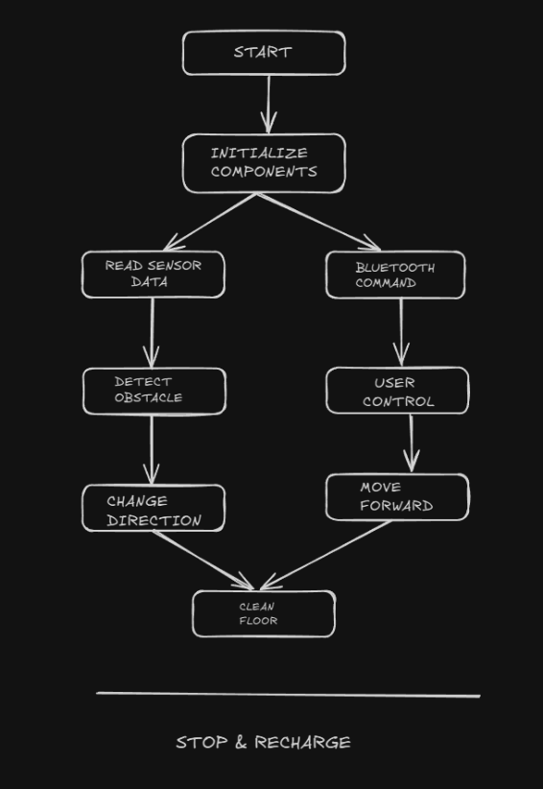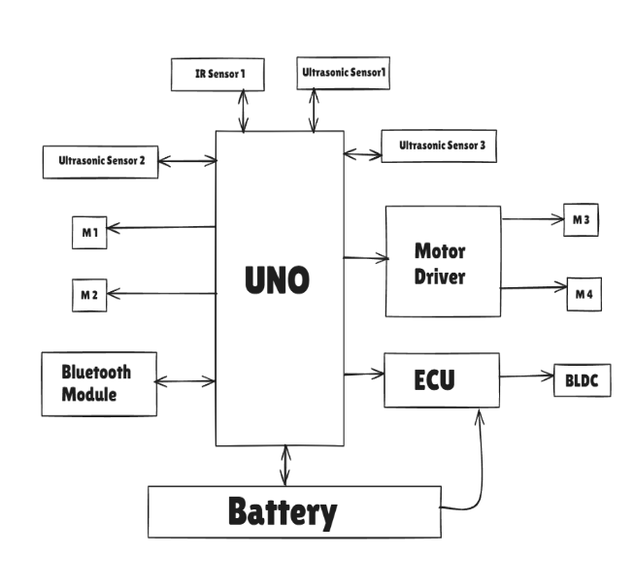

Figure 2: Flowchart of the Proposed system

Figure 1: Proposed system overview

The cleaning system navigates through the intended area, utilizing its sensors to navigate efficiently and avoid obstacles. The integration of motorized brushes and suction systems efficiently removes stains, dirt, and dust from the floor surface. The device is capable of cleaning dry and wet surfaces, enabling it to be utilized in a broad range of environments, including residential, office, and commercial settings. Users are provided with the flexibility to adjust cleaning schedules and settings using the mobile application, thus enabling the device to be tailored to specific needs. The application of smart navigation technology enables the system to delineate the cleaning area and optimize its path, minimizing redundancy and maximizing productivity. This automation minimizes manual intervention, thus making the cleaning process convenient and time-saving. The intelligent floor cleaning system is especially useful for people with busy lives, the elderly, and companies looking for cost-effective maintenance solutions. Compared to traditional cleaning procedures, the automated system requires much less human involvement while simultaneously increasing cleaning efficiency. With its compact size, it can easily maneuver tight corners and spaces, which are usually hard to reach manually. The addition of real-time monitoring via Bluetooth connectivity enables users to monitor cleaning activity and battery life remotely. This technology not only increases cleaning efficiency but also promotes a healthier living space by eliminating allergens and bacteria. As technology advances, intelligent cleaning appliances like these will be at the forefront of the upgrading of domestic and commercial cleaning procedures. With an easy-to-use interface, efficient operation, and self-sustaining nature, the intelligent floor cleaning system is a leap towards intelligent and easy-to-use cleaning appliances, allowing easy mobility across a variety of surfaces.

|  |  |  |
| --- | --- | --- |
| **S/N** | **Components** | **Quantity** |
|  | Arduino Uno | 1 |
|  | Servo motor | 3 |
|  | *Motor driver L298N* | 1 |
|  | Water Pump | 1 |
|  | DC Motors | 5 |
|  | Bluetooth Sensor HC-05 | 1 |
|  | Ultrasonic Sensor | 1 |
|  | Connecting Wires | As Required |
|  | Wheels | 4 |
|  | Rotating Cotton Bush | 1 |
|  | Vacuum Pump | 1 |

**Table 1: components and quantity**

1. RESULT AND DISCUSSION

The study developed an autonomous floor cleaning robot controlled via an Arduino Uno microcontroller. Key components include DC motors for movement, ultrasonic and IR sensors for obstacle detection and navigation, a Bluetooth module for remote control, and cleaning mechanisms like brushes and suction. The system can operate in both dry and wet cleaning modes. It uses sensors to map its environment, avoid obstacles, and optimize cleaning paths. Users can control and monitor the robot remotely via a smartphone app. Key advantages include: - Reduced manual labour and time savings for cleaning tasks - Improved cleaning efficiency and consistency - Ability to reach tight spaces and corners - Cost-effective solution for homes and businesses - Promotes better hygiene by reducing allergens and bacteria.

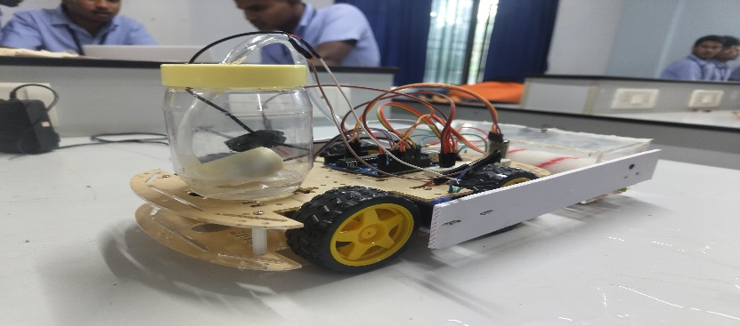

1. CONCLUSION

The idea of the Smart Floor Cleaning System is an appealing option for automating a common household chore: floor cleaning. The combination of the Arduino UNO microcontroller, motor driver L298N, Bluetooth module HC-05, servo motors, and water pump increases the system's functionality to clean more efficiently and accurately. The application of servo motors facilitates lifting and arm movement, thus allowing the cleaner to effectively deal with a vast variety of surfaces. The application of the water pump also allows the system to eject water, further facilitating the cleaning process by effectively removing dirt and grime. The utilization of Bluetooth technology allows the system to be conveniently controlled through a mobile application.

REFERENCE

1. Indronil Dey Niloy, Sayed Mohaiminul Hoque, Mashfiqul Hoque, Afif Bin Arfan, Israt Jahan, Islam Bin Mursalin, Mohammad Shidujaman, Mohammad Rejwan Uddin, and Mahady Hasan. **"Smart Floor Cleaning Robot."** *Fab Lab IUB, Independent University, Bangladesh.*DOI:10.1109/TENSYMP55890.2023.10223665. Published on ResearchGate: <https://www.researchgate.net/publication/373709780>.
2. Sharada L. Kore, et al. **"Floor Cleaning Smart Robot."** *International Journal of Engineering Research and Applications (IJERA).* ISSN: 2248-9622, Vol. 12, Issue 9, September 2022, pp. 61-65. *Department of E&TC, BVCOEW, Pune, Maharashtra, India.* Published on IJERA:[www.ijera.com](http://www.ijera.com).ResearchGate:<https://www.researchgate.net/publication/363503605>.
3. Prof.Dattatray M. Kumbhar, Mrs.Vidya Shetti. **"Smart Floor Cleaning Robot."** *Journal of Emerging Technologies and Innovative Research (JETIR).* ISSN: 2349-5162, Volume 7, Issue 10, October 2020. *E&CE Department, HSIT, Nidasoshi, Karnataka, India.* Published on JETIR: www.jetir.org
4. Pooja D. Rathod, Puja V. Wandile, Kiran S. Mohitkar, Pallavi G. Jiwtode. **"Multipurpose Smart Floor Cleaning System by Using Android Device."** *International Journal of Scientific Research in Science, Engineering and Technology (IJSRSET).* Print ISSN: 2395-1990, Online ISSN: 2394-4099, Volume 4, Issue 7, 2018. *Electrical Engineering Department, Datta Meghe Institute of Engineering, Technology and Research, Salod (Hirapur), Wardha, Maharashtra, India.* Themed Section: Engineering and Technology. Published on IJSRSET
5. Shritika Walker, Prashant Tiwari, Vishal Kumar, Kunal Limbu, Amay Tawade. **"Smart Floor Cleaning Robot Using Android."** *Department of Electronics and Telecommunication, Dr. D.Y. Patil Institute of Engineering, Management and Research, Akurdi, Pune, Maharashtra, India.* *International Journal of Engineering Research & Technology (IJERT).* E-ISSN: 2395-0056, p-ISSN: 2395-0072, Volume 09, Issue 01, January 2022. Published on IJERT